What is Fast API in python:

1.modern, high performance web frame work used to built APIs with python
Features:
1.high performance: ASGI - concurrent access
2.Automatic data validations: pydantic (enforce data type)
if poor formatted input - fast api catch the error and send the browser reponses
3.Fewer bugs and fast development

API: Application Programming Interface
Set of rules that allow two software applications to communicate and exchange the data between them
Advantages:
1.communications - allow two applications to communicate
2.code reusability - same backend functionality
3.Automaions - exchange data and perform task automatically
4.security - use authentication and authorization for controlled access
5.Integrity - connect different systems like payment gateway, database, third party systems
6.scalability - backend support multiple clients
7.Easy data exchange - use json format to transfer data

UI Layer ---------------- API layer -------------------------- Database

presentation Business Logic: Data
logic: Web Api java spring
Angular express js
React FAST Api
Embed js
Endpoints

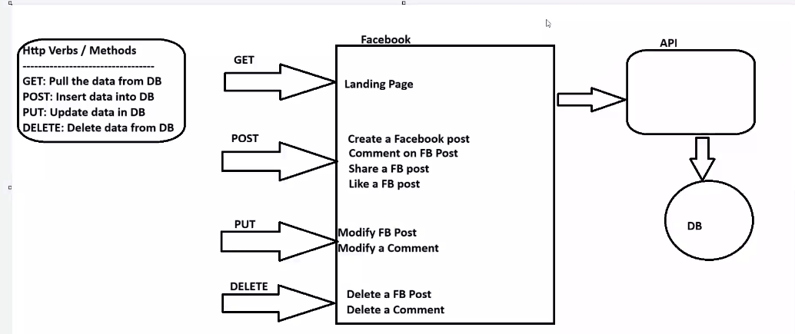

Any operations in Web will perform any these four methods.
- Create (ADD) – POST
- Read – GET
- Update – PUT
- Delete – DELETE

JSON - JavaScript Object Notation
ightweight data format used to store and exchange data between applications
language independent - like python java, javascript can use it
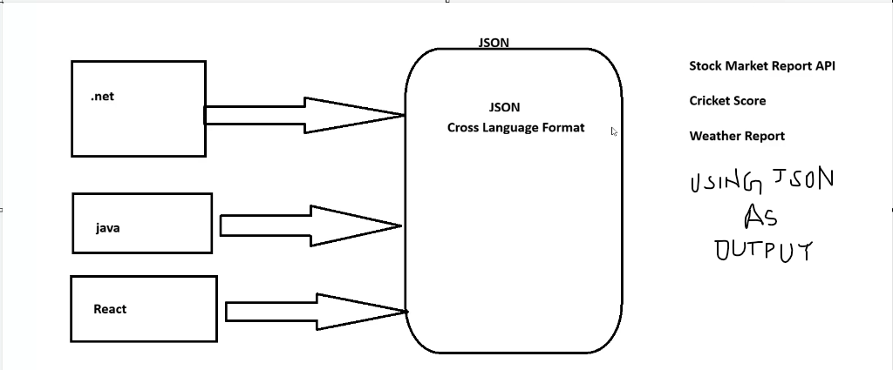
API way of Communication:
HTTP status code – 3 digit number a server send to browser to show the result of request
Api communicates back with status code
HTTP meaning
200 success -- OK
404 page not found
401 Unauthorized
201 Insert done (request success and new resource created)
500 Internal server error

